N.A.B.C.A. POLO AND
HOODIE ORDER FORM

We want to present you with NABCA wear.
The following Polos can be ordered in either Black or White, as well as Male or Female sizes.
The Hoodies can be ordered in Male Sizes only.
You can pick from sizes Small up to 5X at the same price.
The Hoodies have the following quality:
- Fabric: 8.4-oz 80/20 cotton/polyester blend fleece
- Hoodie
- Hood with dyed-to-match drawstring
- Set-in sleeves
- Rib-knit cuffs and waistband
- Front pouch pocket
The Polos have the following quality:
- Fabric: 4-oz polyester with antimicrobial additive
- Moisture-wicking
- Odor-resistant
- Snag, fade, wrinkle, stain, and shrink resistant
- Rib-knit collar
- Four-button placket with dyed-to-match buttons
- Contrasting neck tape
- Set-in sleeves
- Self-fabric cuffs and hem
- Side vents
Please complete the following information and email to Father Reggie at fatherreggie@gmail.com. You can either pay upfront by sending a check to Pam Harris or at our Annual Meeting. Shirts will be delivered at our Annual Meeting, but if you would like them mailed to you please add an additional $12 per order. We hope you enjoy them.
Orders must be received by August 1, 2024.

NABCA ORDER FORM FOR POLO AND HOODIES
Polo Shirts are $30 Each | Mail Checks to :  NABCA  Attn: Pamela Harris, Treasurer  4451 Telfair Blvd  Apt. 5003  Camp Springs, MD 20746
Hoodies are $28 Each

Shipping is $12 per order

Item | Quantity | White | Black | Hoodie | Polo | Small - 5X | Male | Female
1
2
3
4
5
6
7
8

Name:
Shipping Address if shipping:
Total Items Ordered:
Total Cost:
Payment Method: | Mailing Check | Pick up at meeting
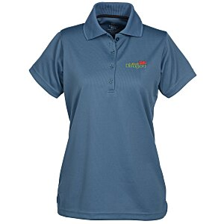
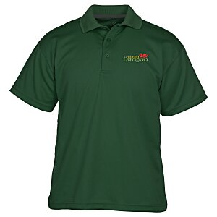
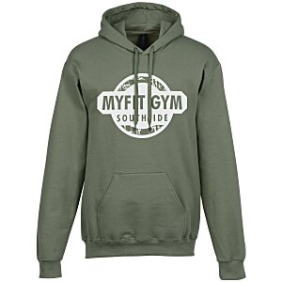
Ladies’ Men’s Hoodie

