

**2024 Annual Meeting of the**

**National Association of Black Catholic Administrators**

**September 18-20, 2024**

**NABCA Member Registration Fee - $150.00**

**Guest Registration Fee - $100.00**

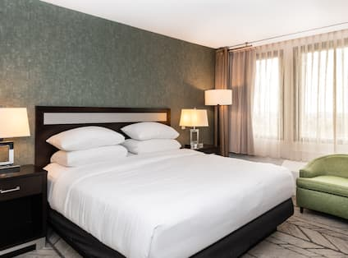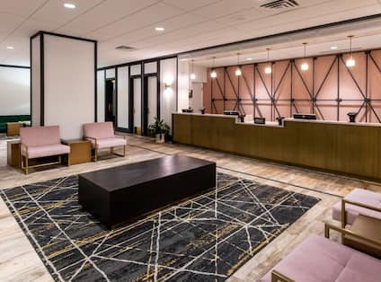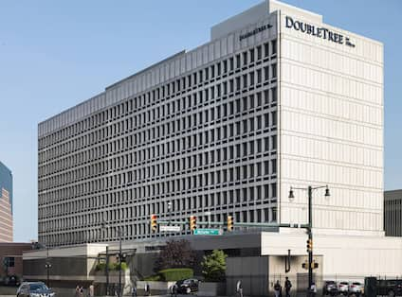

**LOCATION:**

**Double Tree by Hilton, Newark Penn Station**

  1048 Raymond Blvd, Newark, NJ 07102

***973-622-5000***

Room Rate: $189.00 per night

***Booking Link;***[***NABCA ROOM BLOCK (hilton.com)***](https://www.hilton.com/en/attend-my-event/ewrhddt-nab-d42b5802-5187-42df-ab49-44dee98a19c0/)

***Cutoff date; 08/21/24.***

*Our hotel is connected to Newark Penn Station by an indoor walkway, 20 minutes from midtown Manhattan. We're a 10-minute walk from the New Jersey Performing Arts Center and the Prudential Center. Our free shuttle will take you to Newark International Airport, five miles away.*

*Every stay starts with our signature warm chocolate chip cookie.*

**Check-in 4 pm →Check-out 11 am**

**HOTEL AMENITIES:**

|  |  |
| --- | --- |
| **Parking:** | Self-parking: $47.55 per day |
| **Airport Shuttle:** | Newark International Airport: Available, Based Upon Availability  John F. Kennedy International Airport: Not available  La Guardia Airport: Not available |
| **Smoking Policy:** | We are a 100% non-smoking hotel. A fee of up to 250 USD will be assessed for smoking in the hotel. Please ask the Front Desk for locations of designated outdoor smoking areas. |
| **Dining:** | The Junction Bar and Grill is conveniently located on the upper lobby and offers breakfast, lunch and dinner.  Bistro Six Five Zero serves delicious and innovative dishes from sesame crusted ahi tuna to flatbread pizzas and a great range of healthy salads. The BISTRO Lounge is perfect for a relaxing cocktail or beer. |
| **Pets** | No pets allowed. (Service support animals welcome) |