Black Catholic History Month
November

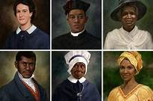

Resource Package
Office of Black Catholic Ministry
Archdiocese of Baltimore
Adrienne Curry, M. Div., Director
November is Black Catholic History Month
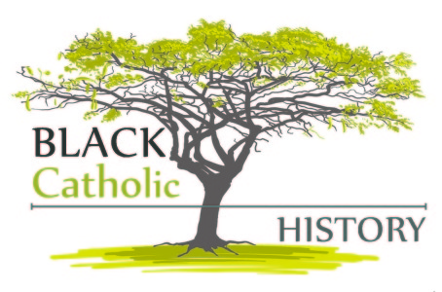
Black Catholic History Month was established in 1990 through the advocacy of the National Black Catholic Clergy Caucus. During the same year, the first celebration of Black Catholic History Month began in November in various cities in the United States with the celebration of St. Martin de Porres’ Feast Day. On November 3rd of threat year, a liturgy celebrated the 150th anniversary of his transition to eternal life. In the world today there are more than 200 million people of African descent in the Roman Catholic Church.
The reason for the selection of November to celebrate Black Catholic History is the number of important dates within this month:
- November 1- All Saints Day- an opportunity to review the lives of saints of African descent living in the first 300 years of Church history;
- November 2- All Souls Day- a time to remember the Africans lost in the cruel treatment in the Middle Passage;
- November 3- The Feast Day of St. Martin de Porres, the only saint of African descent in this hemisphere;
- November 20- the death of Zumbi Palmares in Brazil, the South American founder of a free state for Blacks.
Black Catholic History Month is a time for us to celebrate the contributions of Black Catholics to the Roman Catholic tradition. Six men and women of African descent who ministered in the U.S. are on the road to sainthood. Three of them have taken the first step toward sainthood by being declared a “servant of God”- which means the Congregation for the Causes of Saints has enough evidence to open a case. The three others have reached the second step of being declared “venerable”- which means the pope has decided that the person has lived a life of “heroic virtue.”
The remaining steps- beatification and canonization- require proof of a miracle at each state. Please pray to each of these candidates and learn about their lives.

Venerable Pierre Toussaint (1776-1853)
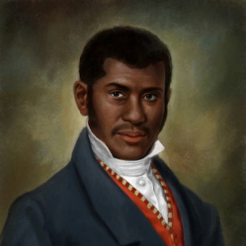
Venerable Pierre Toussaint, a philanthropist and founder of many Catholic charitable works, was born a slave in Haiti and brought from Haiti to New York as an apprentice under a popular hairstylist in the city. He eventually became the most sought after hairdresser of high society women. Upon the death of his master, he gained his freedom and quickly succeeded as one of the country’s first black entrepreneurs. He became quite wealthy, but instead of spending lavishly on himself, he supported the Church and the poor. He and his wife sheltered orphans, refugees and others out on the treats and in their home. He founded one of New York’s first orphanages and raised money for the city’s first cathedral. During the yellow fever epidemics, Toussaint would risk his life to help others by nursing the sick and praying with the dying. “I have never felt I am a slave to any man or woman but I am a servant of Almighty God who made us all. When one of his children is in need, I am glad to be His slave.”

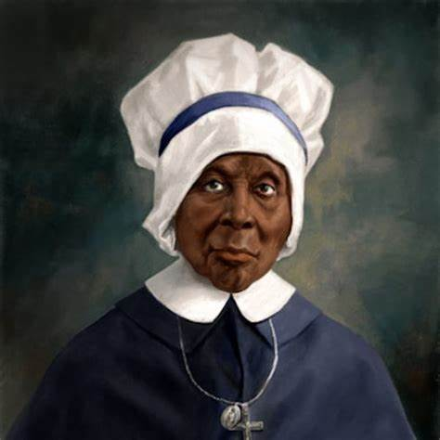
Venerable God Mother Mary Elizabeth Lange (1784-1882)
Servant of God Mother Mary Lange was born Elizabeth Lange, born in Cuba. She was the foundress and first Superior General of the Oblate Sisters of Providence (1829-1832), the first religious congregation of African American women in the history of the Catholic Church. On July 2, 1829, Elizabeth and three other women professed their vows and became the Oblate Sisters of Providence with the goal of educating and evangelizing African Americans. They educated youth and provided a home for orphans. Freed slaves were educated and at times admitted into the congregation. They nursed the terminally ill during the cholera epidemic of 1832, sheltered the elderly, and served as domestics at St. Mary’s Seminary. Mother Mary Lange practiced faith to an extraordinary degree. It was her deep faith, in close union with Jesus, which enabled her to persevere against all odds. She lived through disappointment and opposition until God called her home in 1882 at St. Frances Convent in Baltimore, Maryland.

Venerable Henriette Delille (1813-1862)
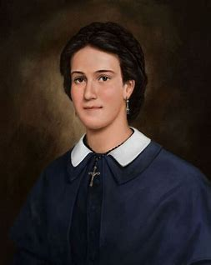
Venerable Henriette Delille was born in New Orleans, Louisiana, where she lived her entire life. For the love of Jesus and responding to the Gospel’s mandate, she was determined to help those in need. Henriette was also a person who suffered as she made her way through live, and she bore many crosses. She taught those around her that sanctity can be attained in following the path of Jesus. It was in this manner that she dealt with her troubles and major obstacles to achieve her goals. Some of the troubles Henriette met were the resistance of the ruling population to the idea of a black religious congregation; the lack of finances to do the work; the taunts and disbelief of people in her mission; the lack of support from both the Church and civil authority; and poor health.
Henriette practiced heroic virtue. She had faith, lived in hope, and practiced love. She was compassionate, forgiving, and merciful. She believed in justice and was not afraid to do what was right in the eyes of God. God blessed her efforts and, in 1842, she founded the Congregation of the Sisters of the Holy Family. Henriette died 20 years later on November 17, 1862. Her funeral was held at St. Augustine Church. Her obituary stated, “… Miss Henriette Delille had for long years consecrated herself totally to God without reservation to the instruction of the ignorant and principally to the slave.”

Venerable Fr. Augustus Tolton (1854-1897)
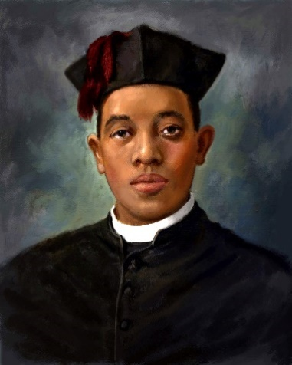
Venerable Augustus Tolton was the first recognized black Roman Catholic priest. A former slave who was baptized and reared Catholic, Tolton formally studied in Rome. He was ordained in Rome on Easter Sunday at the Archbasilica of St. Joh Lateran. Fr. Tolton led the development and construction of St. Monica’s Catholic Church as a black “National Parish Church.” Which was completed in 1893. Tolton’s success at ministering to black Catholics quickly earned him national attention within the Catholic hierarchy. “Good Father Gus,” as many called him, was known for his eloquent sermons, his beautiful singing voice, and his talent for playing the accordion. Fr. Tolton spoke at the First Black Catholic Congress in 1889, in Washington, DC. “The Catholic Church deplores double slavery- that of the mind and that of the body. She endeavors to free us of both. I was a poor slave boy but the priests of the Church did not disdain me. It was through the influence of one of them that I became what I am tonight.”

Servant of God Julia Greeley (1833-1918)
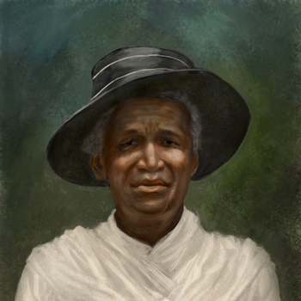
Servant of God Julia Greeley was born into slavery in Hannibal, Missouri sometime between1833 and 1848. Freed by Missouri’s Emancipation Act in 1865, Julia subsequently earned her keep by serving white families in Missouri, Colorado, Wyoming, and New Mexico- though mostly in the Denver area. Julia entered the Catholic Church at Sacred Heart Parish in Denver in 1880 and was an outstanding supporter of the parish. The Jesuits who ran the parish considered her the most enthusiastic promoter of devotion to the Sacred Heart of Jesus they had ever seen. Every month she visited on food every fire station in Denver and delivered literature of the Sacred Heart League to the firemen, Catholics and non- Catholics alike. A daily communicant, Julia had a rich devotion the Blessed Sacrament and the Blessed Virgin and continued her prayers while working. She joined the Secular Franciscan Order in 1901 and was active until her death in 1918. As part of the Cause for Canonization, Julia’s mortal remains were transferred to Denver’s Cathedral Basilica of the Immaculate Conception on June 7, 2017.

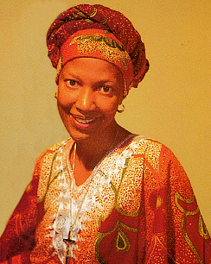
Servant of God Sr. Thea Bowman, FSPA (1937-1990
Sr. Thea Bowman, FSPA was a self-proclaimed, “old folks’ child.” Bowman was the only child born to middle-aged parents, Dr. Theon Bowman, a physician, and Mary Esther Bowman, a teacher. At birth, she was given the name Bertha Elizabeth Bowman. She was born and reared in Canton, Mississippi. As a child, she converted to Catholicism through the inspiration of the Franciscan Sisters of Perpetual Adoration and the Missionary Servant of the Most Holy Trinity who were her teachers and pastors at Holy Child Jesus Church and School in Canton. During her short lifetime, many people considered her a religious sister undeniably close to God and who lovingly invited others to encounter the presence of God in their lives. She is acclaimed as a “holy woman” in the hearts of those who knew and loved her and continue to seek her intercession for guidance and healing.

Ways to Celebrate
- Exhibit symbols that reflect African American Culture: pictures, religious symbols, kente cloth, Bible enthronements.
- Highlight Black Catholic Role Models: The Six Black Catholics on the Road to Sainthood, Black saints, local people in the parish or community.
- Write essays or present plays about Black Catholics
- Create/Develop/Design Liturgical Celebrations/Prayer Services
- Invite Black priests, sisters, deacons, and lay leaders to celebrate prayer services and other activities with the young people of your parish.
- Incorporate music from Lead Me, Guide Me, the African American Catholic Hymnal.
- Recite/Create a prayer for the Six Black Catholics on the Road to Sainthood.
- Display the African American Josephite Calendar.
- Display pictures of the Six Black Catholics on the Road to Sainthood.
- Sponsor a DVD or video showing and facilitate a discussion on African American themes.

FACTS AND FIGURES
Who was the first African mentioned in the Gospels?
The first African, in the New Testament, was mentioned in the Gospel of Matthew, Simon of Cyrene (Matthew 27:32). Simon was pressed into service to carry the cross of Jesus. This even is highlighted in the fifth station of the cross.
Tell the story of the account of the baptism of the Ethiopian eunuch.
In the Acts of the Apostles, Chapter 8:26-40, we read the account of the Ethiopian Eunuch. This person was a Black person baptized by Philip. The Ethiopian Eunuch was the court official in charge of the treasury of the Queen of the Ethiopians. “Ethiopian refers to a person of color from Africa. The Greeks used the word, which means “burnt,” or darker skin.
Was one of the “Wise Men” Black at the birth of Jesus?
In the Infancy Narrative there is a reference to Melchior of Persia, whose likeness remains today in the Christian crib set.

Notable African Catholic Saints
St. Frumentius (d. 380) was from Syria. He was a slave and held a trusted position in the royal court at Axum. Frumentius was a person of great faith. He opened chapels in Ethiopia, and did mission work. Frumentius was very instrumental in the conversion of the Ethiopian King Ezana. After his freedom, he was later ordained Bishop by St. Athanasius, the Patriarch of Alexandria. Frumentius was the first Bishop of Ethiopia.
How many Popes were African? Three
St. Victor I (186-197) from the Roman province in Africa; St. Miltiades (311-314) born in Rome of African descent; and St. Gelasius (492-496) born in Rome of African descent.
Did you know about these African people?
St. Zeno was bishop of Verona in Italy. He died in 372.
St. Maurice and a group of Ethiopian Christian soldiers called the “Theban Legion” belong to the Roman army. In the Middle Third Century, this group while servicing in Switzerland were told to take part in a heathen service, but refused. The group was later butchered.
St. Moses the Black was a convert and leader of a band of monks in the desert who were martyred about 410. He was one of the most in influential monks in the world. Because of Moses the Black, many women and men sought a life of prayer in the desert in the cenobitic style of sharing means and community in Upper Egypt and Ethiopia.
St. Monica was the Mother of St. Augustine. Monica was an African woman of great faith who prayed for her son to turn against evil. Before her death, Monica had the great joy of knowing that her son had come back to God and used his talents to build up Christ’s Church.
St. Augustine was born in Tagaste, Africa, and was the son of Monica. At the age of 33 he turned back to God as was baptized Catholic. Augustine was later ordained a priest and later Co-Bishop of Hippo. He led a holy and simple life, writing over 200 books, letters, and sermons. His writings are still read today. St. Augustine’s feast day is August 28.
St. Martin de Porres (1579-1639) was the first African American saint. Martin de Porres was of Spanish and African descent. He was the first Dominican professed Black brother in 1603. Martin de Porres is called “Father of the Poor” because of his charitable acts and his dedication to prayer. He was canonized a saint in 1962.
St. Esteban (Stephen) (d. 1536), native of Morocco, was a member of the Spanish exploration party of Panfilo de Naruaez.
St. Charles Lwanga and the Ugandan Martyrs. In the resource Black Christian Saints and Other Exemplary Black Men and Women, (pgs. 128-131), we read the story of faith filled witness of the Ugandan Royal Pages. This story highlights how even to the point of death they didn’t give up their faith, and celebrated their execution with joy. The Martyrs of Uganda were beatified in 1902 and canonized by St. Pope Paul VI on October 18, 1964.
Who is the founder of the Blessed Sacrament Sisters?
St. Katherine Drexel was the founder of the Sisters of the Blessed Sacrament and the first and only Black Catholic University in the United States, Xavier University in New Orleans, Louisiana. She was canonized on October 1st, 2000, becoming the second recognized American born saint.
Doctor Lena Edwards (1901-1986). Dr. Lena Edwards was born in Washington, D.C. She was a dedicated physician, and a mother of six. Lena was a very sincere Catholic. She was a member of the Third Order of St. Francis, and was also very concerned about the poor. Dr. Edwards was an active member of the Catholic Interracial Council in Washington. In her later years, she taught college at Howard University Medical School, and also began to minister to the Mexican American migrant workers in Texas. Dr. Edwards was a determined woman who addressed the needs of the poor and women. She had a very deep faith and dedicated her life to serving others.
Jean Baptiste Pointe du Sable (d. 1818) was an authentic woodsman and trader, and trusted friend of the Native American people. He was the founder of the city of Chicago.
Harriet Thompson (1853), wrote to Pope Pius IX to plead for the Catholic Church to minister to Black people in New York and address the concerns of racism. This was the beginning of the Black Catholic Movement (Davis, 1990, pgs. 94-95).
Who was the first Black bishop in the United States?
Bishop James Healy, was ordained bishop of Portland, Maine in 1875.
Who was the first Black president of Georgetown University?
Fr. Patrick Healy, SJ in 1874.
Who was the first recognized Black priest?
Fr. Augustus Tolton from Illinois in 1886.

