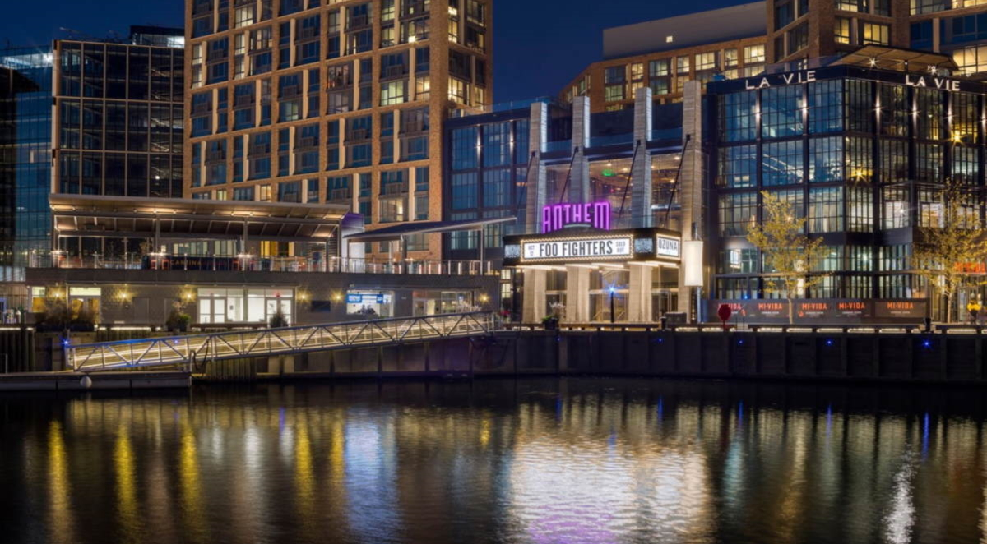
2023 ANNUAL MEETING
OF THE NATIONAL ASSOCIATION OF
BLACK CATHOLIC ADMINISTRATORS
JULY 24-25, 2023
WASHINGTON WHARF DISTRICT

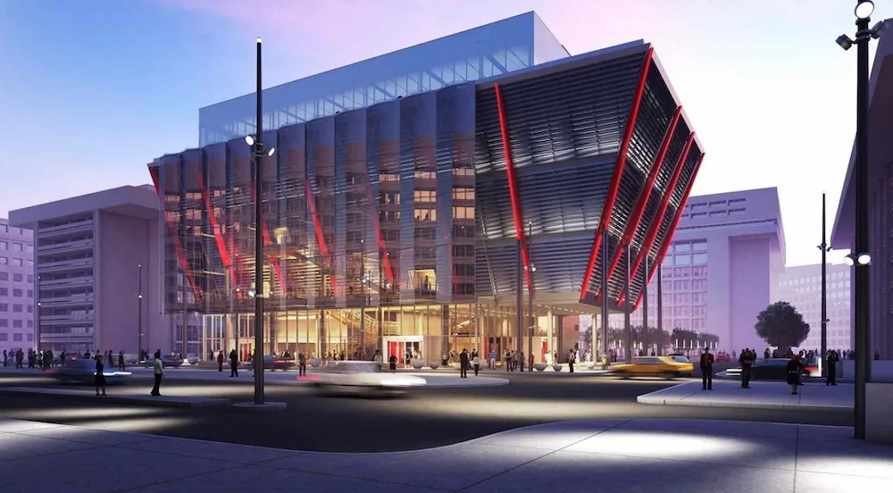

HILTON WASHINGTON DC NATIONAL MALL
d: +1 202 790 5132 t: +1 202 484 1000
f: +1 202 869 1952
480 L’Enfant Plaza SW, Washington, DC 20024, USA
washingtondcnationalmall.hilton.com
hilton.com

Please call to book your reservations ASAP. We will conclude our meeting by 4PM on Tuesday.
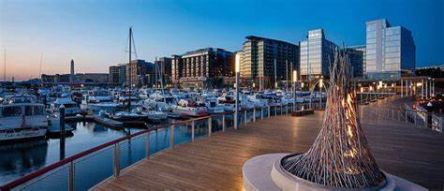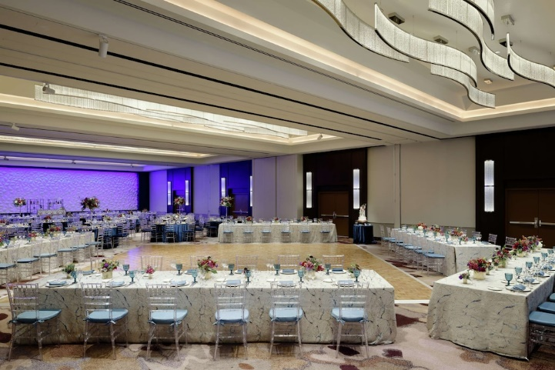

The District Wharf
The District Wharf located on the Potomac River is home to the nation’s longest continually operating open-air fish market. This has transformed into DC’s most exciting waterfront destination. The plentiful entertainment, dining, and retail connects the rest of the District to Southwest & The Wharf and features an accessible riverfront. Make your way down by the water with a quick walk, bike ride, or use public transportation. Enjoy one of the four public piers and parks, locally grown dining concepts, and a show at one of DC’s newest music venues. The Wharf is conveniently located only four blocks from the Hilton Washington DC/National Mall/Wharf hotel.

Local Attractions Near our site:
- Food
- The Anthem
- District Pier
- Shuttle
- Pearl St. Warehouse
- MGM Casino
- The Torch and more!
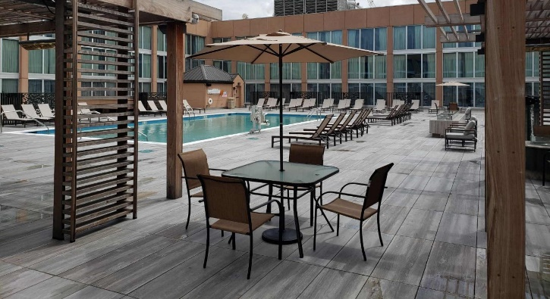

2023 ANNUAL MEETING
OF THE NATIONAL ASSOCIATION OF BLACK CATHOLIC ADMINISTRATORS
July 24-25, 2023
NABCA Member:
Name:________________________________________________
(Last) (First) (Preferred Name)
Diocese:_______________________________________________
Arrival Date Departure Date
_____ Yes, I will attend the annual meeting.
_____ Number of people you are registering.
_____ No, I will not attend the annual meeting.
The NABCA Membership Registration fee is $150.00. Guest registration fee is $100.00.
Deadline for payment of registration fee[s] is July 10, 2023.
Please make registration checks payable to:
National Association of Black Catholic Administrators
Attn: Pamela Harris, Treasurer
4451 Telfair Blvd, Apt. 5003
Camp Springs, MD 20746

